**Smart Fuel Meter User Manual**

**Setting up the device**

* Install Arduino IDE which is relevant in Windows, Linux or Mac OS. (<https://www.arduino.cc/en/software>)
* Download CP210x driver then extract zip file & install driver.

(<https://www.silabs.com/developers/usb-to-uart-bridge-vcp-drivers>).

* If use LOLIN NodeMCU V3 download CH340 driver & install same in above method (<https://sparks.gogo.co.nz/ch340.html>).
* 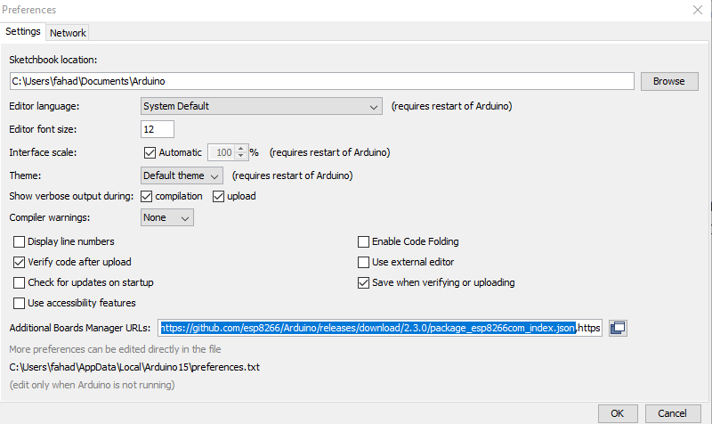Open Arduino IDE & click on file & go to Preferences then paste board manager URL (<http://arduino.esp8266.com/stable/package_esp8266com_index.json>) if there is another URL put comma end of current URL & put above one. Then click OK
* Next go to Tools -> Board -> Board Manager then search esp8266 & install it.
* After that again go to Tools -> Boards -> ESP 8266 Boards -> NodeMCU 1.0 (ESP-12E Module). If someone use LOLIN NodeMCU V3 select Generic ESP 8266 Module.
* Finally select port according to device manager if its Windows PC. (in LINUX & MacOS it differs).

**WIFI Credentials Configuration**

* Open given Code
* Set SSID & Password in given below

**Troubleshooting**

* Serial port not supports
  + Change USB Cable
  + Reinstall CP210x driver or CH340
  + Restart computer
* Sensor reading not displaying in web page
  + Reload the page
  + Copy Local IP Address, close current tab & paste URL in new tab
  + Clean caches and cookies of browser
  + Charge the power bank
  + Contact Manufacturers (+940716032383 / +940761692373 / 0112834904)

**Safety Information**

* Do not place near flammable materials
* Never open lid of enclosure in high humidity days like raining & cloudy